Tier 1 Full-Repository Engineering Task Guide
Generic Harbor Packaging, Prompt, Evaluation, Reward, and Training Design

1. What a Tier 1 Task Is
A Tier 1 repo-engineering task gives an agent one protected session in a complete production repository. The briefing resembles a real issue: it explains observable behavior, compatibility constraints, and required evidence, while leaving diagnosis and implementation open. The final repository is graded by executable deterministic checks. Optional judges explain quality, but they cannot convert broken behavior into a pass.
The benchmark asks whether the final repository satisfies a real engineering contract, not whether the submitted diff matches a reference patch. Any implementation may pass when it satisfies the required behavior, regressions, integration contract, integrity boundary, and any architecture requirement clearly stated in the prompt.

Use the generic task identity <benchmark>/<task-slug> and replace it with the published package name. The task must point to a protected complete production repository at an exact pre-change commit; those placeholders describe the contract and are not agent-facing prompt text.
Property | Tier 1 requirement | Reason
Repository | Complete, production-scale worktree at an exact pre-change commit | Preserves navigation, build, test, and integration complexity
Session | One agent context without staged reviewer feedback | Measures full issue-to-patch execution in one run
Prompt | Natural behavior-first engineering brief | Avoids revealing a PR, patch recipe, or hidden-test map
Success | All critical deterministic gates pass | A judge cannot rescue incorrect behavior
Partial signal | Weighted, labeled training vector | Near misses remain useful without being called solved
Target headroom | Roughly 20-60% strict frontier solve rate after calibration | Avoids trivial or arbitrary tasks

2. End-to-End Flow
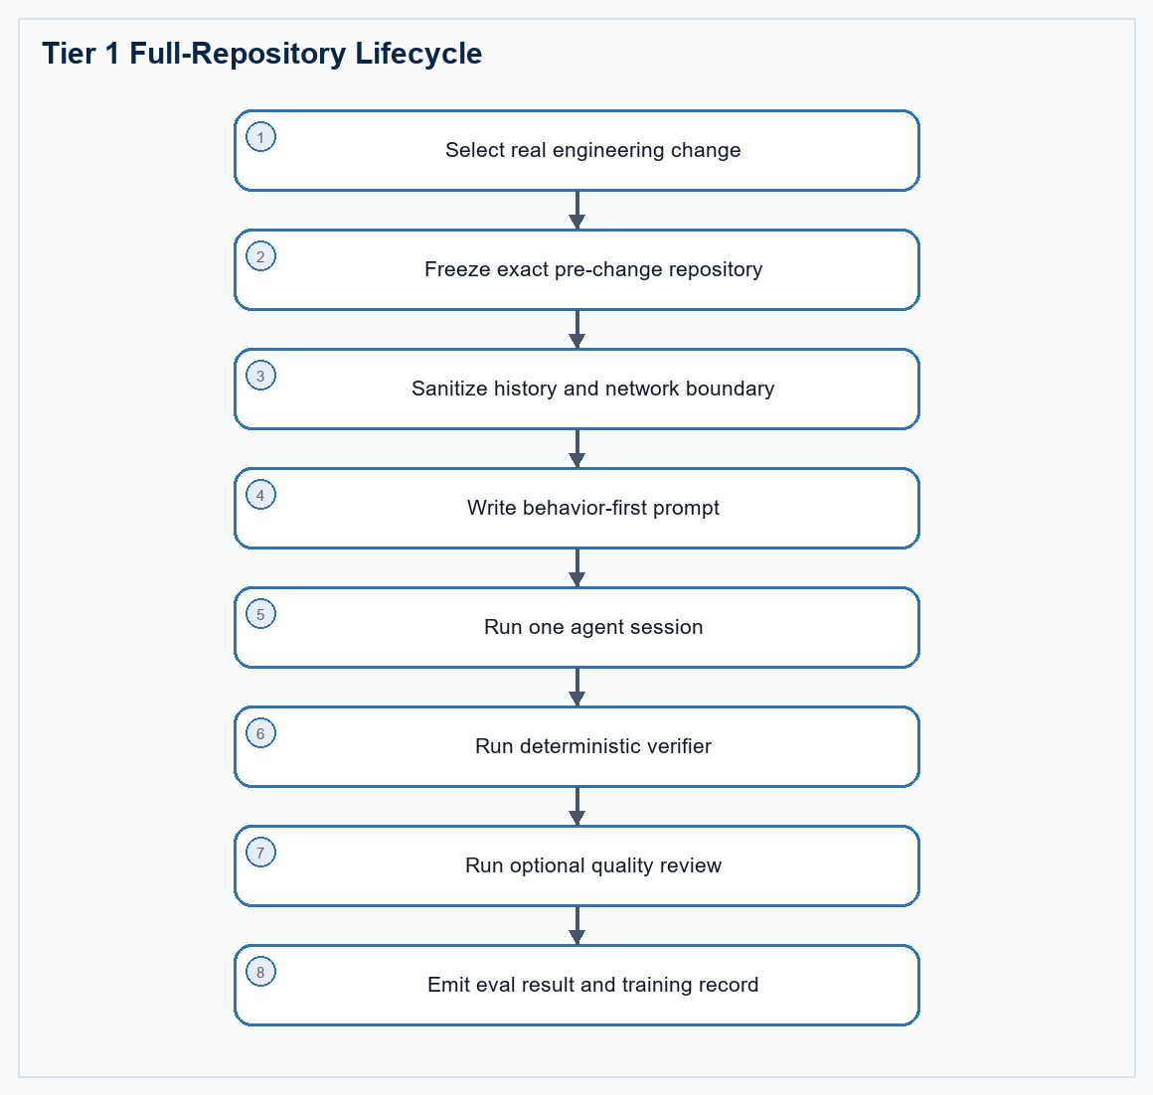
Figure 1. A real repository change becomes a protected single-session task and a labeled result.
The source change provides realism and an author Oracle, but it is not the verifier. Authors add independent hidden variants, regression coverage, integrity checks, and near-miss patches so public change recall alone cannot satisfy the benchmark.

3. Run Procedure
Run no-op, Oracle, and model trials as separate Harbor jobs. Keep unique job names and verify the actual agent and model in result.json before interpreting a score.
# Run from the directory that contains the task folder.
harbor run -p ./<task-directory> -a nop \
--job-name <task>-nop
harbor run -p ./<task-directory> -a oracle \
--job-name <task>-oracle
harbor run -p ./<task-directory> \
-a terminus-2 -m <provider/model> \
--job-name <task>-model
# Inspect the jobs in Harbor's local viewer.
harbor view ./jobs

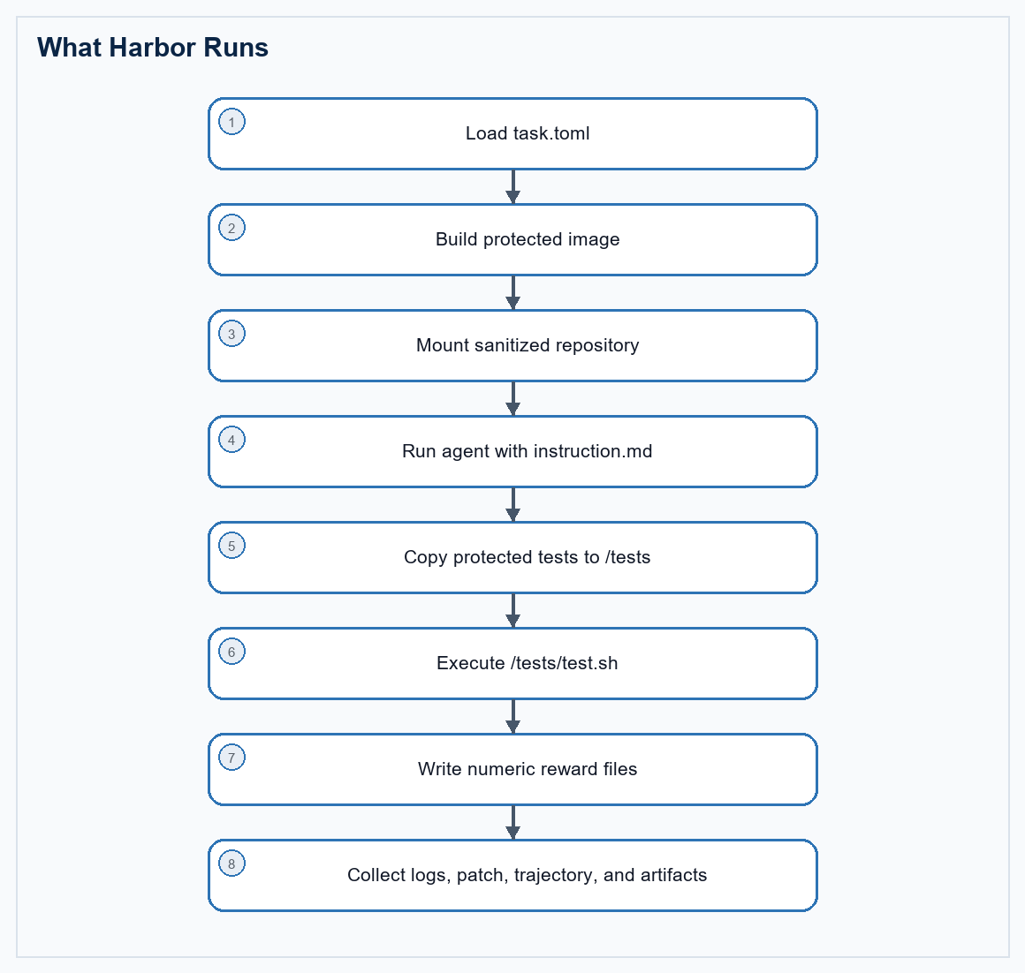
Figure 2. Harbor's task, agent, verifier, and artifact sequence.

Where results appear
/root/harbor-jobs/<job-name>/
`-- <task-name>__<trial-id>/
|-- result.json
|-- agent/trajectory.json
|-- verifier/reward.json
|-- verifier/reward-details.json
|-- verifier/test_output.log
+-- artifacts/

- Read result.json first for agent identity, model, completion state, and aggregate rewards.
- Read reward-details.json and test_output.log for the exact failed check family.
- Inspect trajectory.json and patch.diff before deciding whether a failure is a model miss, verifier defect, timeout, contamination, or infrastructure problem.

4. Recommended Task Package
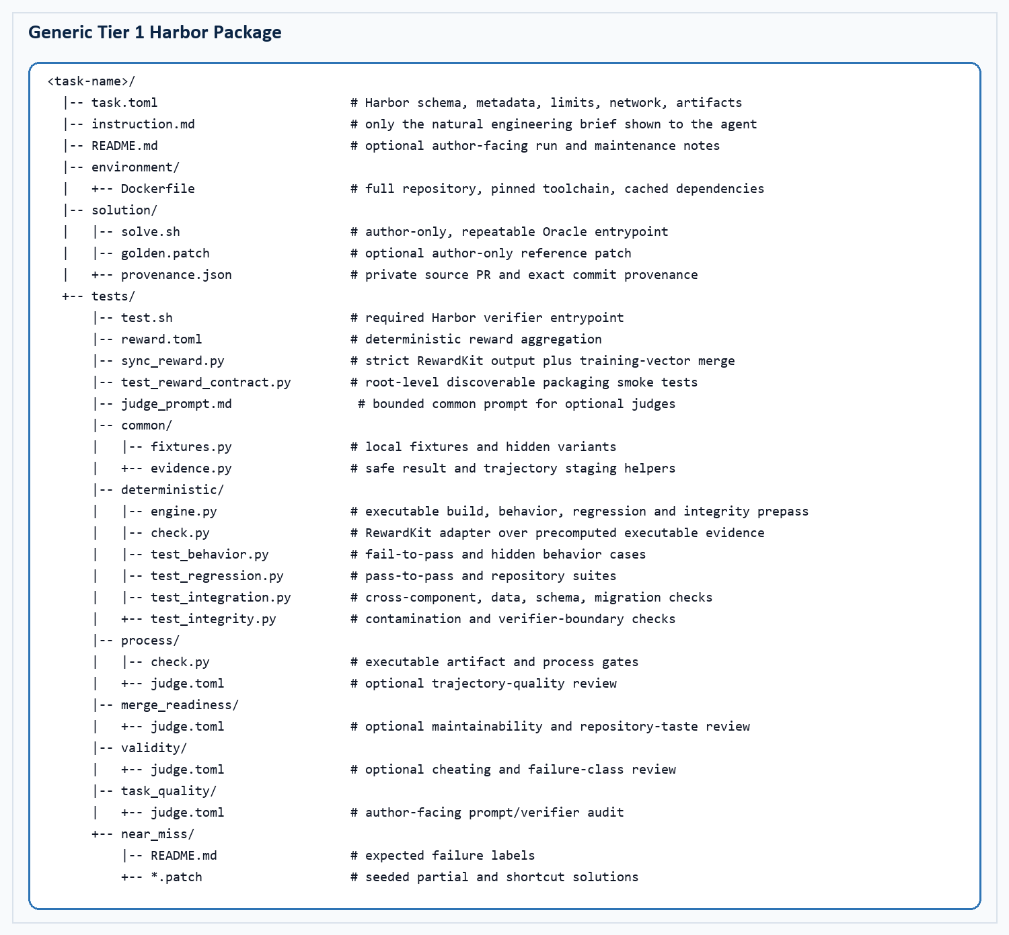
Figure 3. Recommended Tier 1 package with discoverable deterministic tests and separate optional judge dimensions.
<task-name>/
|-- task.toml # Harbor schema, metadata, limits, network, artifacts
|-- instruction.md # only the natural engineering brief shown to the agent
|-- README.md # optional author-facing run and maintenance notes
|-- environment/
| +-- Dockerfile # full repository, pinned toolchain, cached dependencies
|-- solution/
| |-- solve.sh # author-only, repeatable Oracle entrypoint
| |-- golden.patch # optional author-only reference patch
| +-- provenance.json # private source PR and exact commit provenance
+-- tests/
|-- test.sh # required Harbor verifier entrypoint
|-- reward.toml # deterministic reward aggregation
|-- sync_reward.py # strict RewardKit output plus training-vector merge
|-- test_reward_contract.py # root-level discoverable packaging smoke tests
|-- judge_prompt.md # bounded common prompt for optional judges
|-- common/
| |-- fixtures.py # local fixtures and hidden variants
| +-- evidence.py # safe result and trajectory staging helpers
|-- deterministic/
| |-- engine.py # executable build, behavior, regression and integrity prepass
| |-- check.py # RewardKit adapter over precomputed executable evidence
| |-- test_behavior.py # fail-to-pass and hidden behavior cases
| |-- test_regression.py # pass-to-pass and repository suites
| |-- test_integration.py # cross-component, data, schema, migration checks
| +-- test_integrity.py # contamination and verifier-boundary checks
|-- process/
| |-- check.py # executable artifact and process gates
| +-- judge.toml # optional trajectory-quality review
|-- merge_readiness/
| +-- judge.toml # optional maintainability and repository-taste review
|-- validity/
| +-- judge.toml # optional cheating and failure-class review
|-- task_quality/
| +-- judge.toml # author-facing prompt/verifier audit
+-- near_miss/
|-- README.md # expected failure labels
+-- *.patch # seeded partial and shortcut solutions

Why this clears the warnings
Set metadata.benchmark_type to swe-bench for this repo-engineering family. Keep tests/test.sh, add tests/reward.toml, and place executable pytest cases in conventionally named tests/deterministic/test_*.py modules. Use one environment-level allow_internet = false baseline and omit phase-level network_mode overrides. This avoids asking providers to change network policy after the container has started.

File responsibilities
Path | Role | Must contain | Must not contain
task.toml | Harness contract | Schema, task identity, benchmark type, timeouts, resources, network and artifacts | Secrets, source PR URL, or unsupported fields
instruction.md | Agent brief | Symptom, invariant, preserved behavior, constraints and executable evidence | Golden function, exact file list, PR number, hidden test names or patch recipe
environment/Dockerfile | Reproducible runtime | Sanitized full repo, pinned toolchain, cached dependencies and output directories | Reachable future history, remotes, solution, tests or scored network installs
solution/ | Author Oracle | Repeatable solve.sh, optional patch, private provenance | Anything mounted for the solving agent
tests/test.sh | Verifier entrypoint | Absolute paths, deterministic execution, numeric fail-safe reward and bounded logs | Network installs, swallowed missing tests or nonnumeric rewards
tests/deterministic/test_*.py | Executable truth | Hidden behavior, regressions, integration, robustness and integrity assertions | Golden-diff comparison or only the public example
judge.toml | Optional semantic review | Bounded files, explicit rubric and no-binary-rescue rule | Unbounded repository access or authority over deterministic truth

5. Harbor Metadata and Warning Fixes
Use Harbor's current nested task schema. metadata.benchmark_type is required by the benchmark validator used here even though Harbor allows arbitrary metadata. For a Tier 1 repository-engineering task, declare swe-bench unless the task genuinely belongs to another listed benchmark family.
schema_version = "1.3"
artifacts = [
"/app/output/reproducer.sh",
"/app/output/diagnosis.json",
"/app/output/verification.json",
]
[task]
name = "<benchmark>/<task-slug>"
description = "A full-repository engineering task stated as an observable issue."
keywords = ["repo-engineering", "full-repository", "tier-1", "<language>"]
[metadata]
benchmark_type = "swe-bench"
category = "software-engineering"
language = "<language>"
tier = "core-repo-engineering"
repository = "<owner/repository>"
base_commit = "<exact-pre-change-commit>"
expert_time_estimate_hours = 12.0
[agent]
timeout_sec = 21600.0
[verifier]
timeout_sec = 5400.0
[environment]
build_timeout_sec = 7200.0
allow_internet = false
cpus = 8
memory_mb = 16384
storage_mb = 65536

Warning | Cause | Minimal correction | Verification
Missing [metadata].benchmark_type | The task has metadata but no recognized benchmark family | Add benchmark_type = "swe-bench" under [metadata] | Reload or lint the task and confirm the warning disappears
No tests found under tests/ | Only a custom check.py is present, filenames are not discoverable, or tests were omitted from the archive | Keep tests/test.sh and add at least one real tests/deterministic/test_*.py module | List the packaged archive and run the no-op verifier
Agent network policy differs from baseline | agent or verifier network_mode overrides disagree with a fixed environment that cannot change policy after startup | Remove phase-level network_mode fields and set environment.allow_internet = false once | Inspect task.toml and confirm agent and verifier inherit the same offline baseline
Verifier produced no reward | test.sh exited before writing a reward | Always write numeric reward.json or reward.txt; fall back to zero on verifier error | Force one test failure and confirm Harbor records zero

Package pre-flight
# Required Harbor entrypoints and discoverable deterministic tests.
test -f task.toml
test -f instruction.md
test -f environment/Dockerfile
test -f solution/solve.sh
test -f tests/test.sh
test -f tests/reward.toml
find tests/deterministic -type f -name 'test_*.py' -print -quit | grep -q .
# Metadata warning must be absent for this task family.
grep -q '^benchmark_type = "swe-bench"$' task.toml
# Use one fixed offline environment baseline. Phase-level overrides can trigger
# a provider warning when network policy cannot change after container start.
grep -q '^allow_internet = false$' task.toml
! grep -q '^network_mode' task.toml
# Scripts should use Unix line endings and be executable in the packaged task.
file tests/test.sh solution/solve.sh

Archive note
Before publishing a ZIP or registry package, inspect the archive itself. Confirm tests/test.sh, reward.toml, and test_*.py files are present, shell scripts use LF line endings, and solution/verifier files are not copied into the agent image.

6. Environment and Dependencies
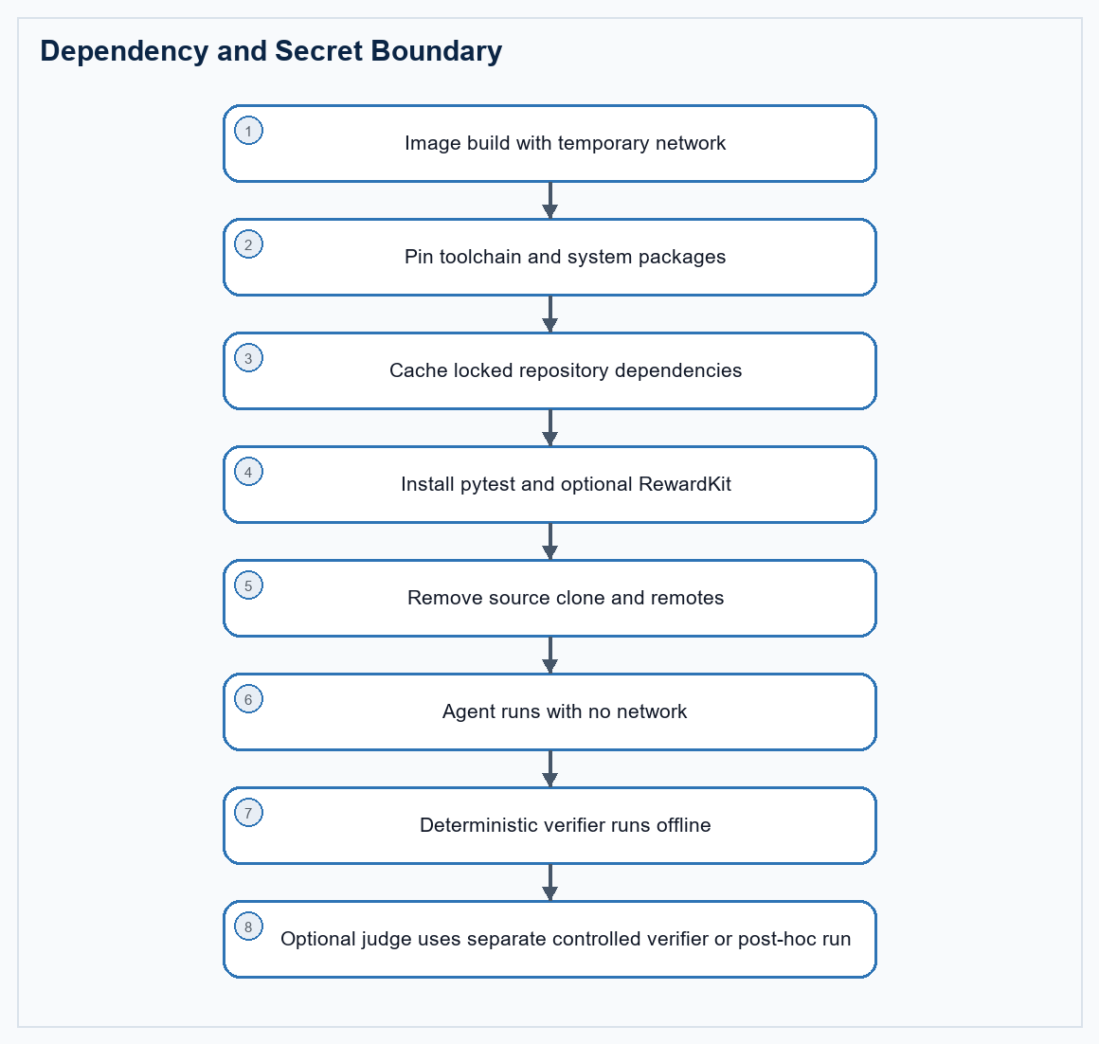
Figure 4. Dependencies are installed before scoring; judge credentials remain outside the agent boundary.
Dependency | Location | Pin or requirement | Purpose
Repository toolchain | Agent/environment image | Pinned compiler, package manager, native libraries and build tools | Build and test the real repository
Locked repository dependencies | Environment image cache | Language lockfile dependencies and required runtime assets | Keep every scored run offline and repeatable
Python | Isolated verifier runtime | Python 3.12 or newer for harbor-rewardkit 0.1.7 | Keep verifier packages compatible with non-Python repository images
pytest | Verifier runtime | Pin a validated version, for example 8.3.5 | Discover and execute test_*.py behavior and regression suites
harbor-rewardkit | Verifier runtime | Pin the tested package; use [all] only when judge/document extras are needed | Weighted criteria, multiple reward dimensions and optional judges
Git/ripgrep/jq | Environment image | Pinned OS packages where practical | Repository inspection, integrity checks and JSON handling
Judge provider client/key | Separate or post-hoc verifier only | Runtime secret plus controlled network access | Optional process, validity and merge-readiness review

Generic Dockerfile pattern
FROM <pinned-language-image>
ARG BASE_COMMIT=<exact-pre-change-commit>
ARG PYTHON_VERSION=3.12
ARG PYTEST_VERSION=8.3.5
ARG REWARDKIT_VERSION=0.1.7
# Install the repository toolchain during image build. RewardKit 0.1.7 needs
# Python 3.12 or newer, so do not assume the language base image is sufficient.
RUN <system-package-install> git ca-certificates ripgrep jq tmux
RUN <install-or-bootstrap-python-3.12>
RUN python3.12 -m venv /opt/verifier-venv \
&& /opt/verifier-venv/bin/python -m pip install --no-cache-dir \
"pytest==${PYTEST_VERSION}" \
"harbor-rewardkit[all]==${REWARDKIT_VERSION}" \
&& /opt/verifier-venv/bin/python -c "import pytest, rewardkit" \
&& /opt/verifier-venv/bin/rewardkit --help >/dev/null
ENV PATH=/opt/verifier-venv/bin:<repository-toolchain-path>:/usr/local/bin:/usr/bin:/bin
# Fetch only while building, then export a sanitized worktree without remotes,
# future commits, PR identifiers, solution files, or verifier files.
RUN git clone <repository-url> /tmp/source \
&& git -C /tmp/source checkout --detach "${BASE_COMMIT}" \
&& mkdir -p /testbed \
&& git -C /tmp/source archive "${BASE_COMMIT}" | tar -x -C /testbed \
&& rm -rf /tmp/source
WORKDIR /testbed
RUN <cache-locked-repository-dependencies-and-build-targets>
RUN git init && git add -A \
&& git -c user.name=benchmark -c user.email=benchmark@invalid \
commit -m "sanitized benchmark base"
RUN mkdir -p /app/output /logs/agent /logs/verifier
CMD ["sleep", "infinity"]

- RewardKit is optional for a simple single numeric reward, but recommended when the task needs weighted criteria, multiple training dimensions, or LLM judges.
- Check the interpreter requirement before installing RewardKit. The validated harbor-rewardkit 0.1.7 setup requires Python 3.12 or newer; a Rust, C++, or older Linux base image may ship only Python 3.11.
- Create an isolated verifier virtual environment and put it first on PATH so pytest and rewardkit use the intended interpreter without changing the repository toolchain.
- Install verifier dependencies during image build or in a separate verifier image. Never use pip, cargo, npm, Maven, or apt network installs during scored verification.
- If judges require an API key, inject it only into a separate or post-hoc verifier and allow only the required provider host. The solving agent must not inherit the key or judge network.
- Pin versions that have passed Oracle and no-op validation. The example versions are a starting point, not an instruction to upgrade an already stable task.

7. Prompt Contract
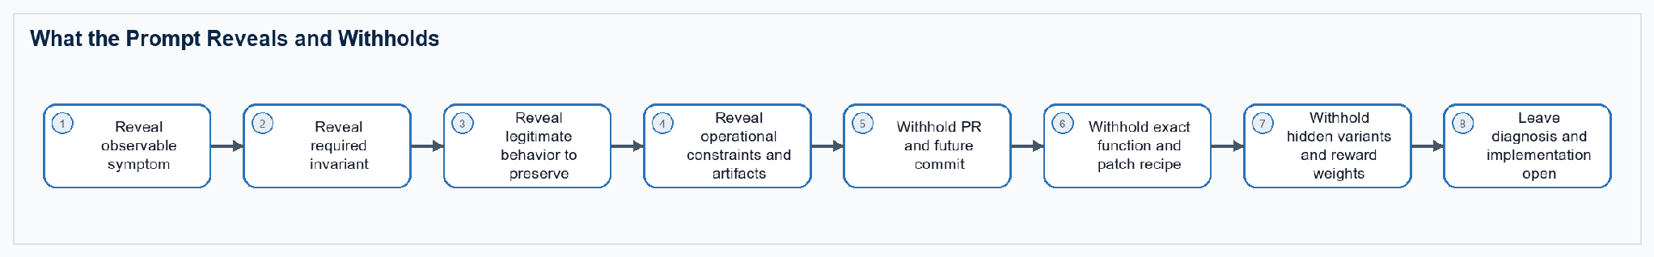
Figure 5. A realistic brief gives sufficient behavioral scope without disclosing the solution.

Generic instruction template
# <Natural issue title>
The complete repository is available at `/testbed`.
Describe the observed user or system problem in normal issue language. Include
one small example only when it helps reproduce the symptom. Do not name the
source pull request, golden commit, hidden test, exact function, or patch recipe.
## Required behavior
- State the invariant that must hold after the change.
- State legitimate behavior that must remain supported.
- State important cross-component, compatibility, data, migration, fault,
performance, ordering, or concurrency constraints.
- Require existing unrelated behavior to remain unchanged.
- Require a coherent repository-level fix, not a hard-coded example.
## Executable engineering evidence
Create under `/app/output`:
1. `reproducer.sh`: an executable offline reproducer whose exit status reflects
the required behavior.
2. `diagnosis.json`: subsystem, observed invariant, root cause, rejected
alternatives, and files inspected.
3. `verification.json`: commands run, cases covered, regression suites, and
remaining risk.
Do not access external services, task-author files, verifier files, Git remotes,
future history, or an upstream solution. Keep the patch mergeable in the full
repository.

Prompt acceptance checks
- A repository maintainer could plausibly file the brief without mentioning benchmarks or evaluation signals.
- The prompt clearly distinguishes behavior that must change from behavior that must remain supported.
- The prompt requires a repository-level outcome but does not list every file or implementation symbol.
- Every critical deterministic gate traces to a stated requirement or ordinary regression expectation.
- Required reports are secondary evidence; prose alone cannot rescue executable failure.

8. Deterministic Tests and Optional Judges
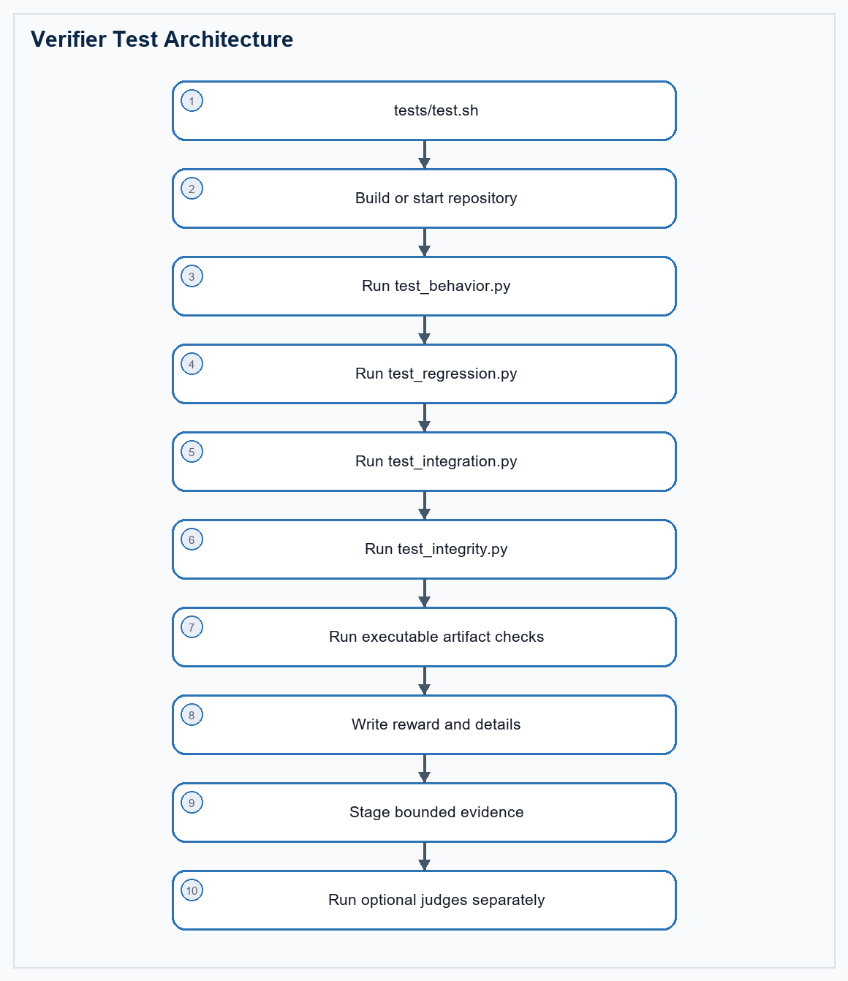
Figure 6. Deterministic truth is executed first; bounded semantic review remains separate.
Check family | Class | Recommended location | What passing proves
Build and startup | Deterministic | tests/deterministic/test_regression.py | The repository and target service or binary build offline
Fail-to-pass behavior | Deterministic | tests/deterministic/test_behavior.py | The original defect is fixed across hidden variants
Pass-to-pass safety | Deterministic | tests/deterministic/test_regression.py | Existing relevant tests and unrelated contracts still pass
Integration/data contract | Deterministic | tests/deterministic/test_integration.py | Callers, schemas, migrations, persistence, or protocols agree
Robustness/performance | Deterministic when stable | tests/deterministic/test_integration.py | Fault, concurrency, resource, rollback, or budget behavior holds
Architecture requirement | Deterministic only when prompted | tests/deterministic/test_integration.py | A required obsolete path or dual model is actually removed
Executable evidence | Deterministic | tests/process/check.py | Reproducer and reports correspond to commands and outputs
Repository integrity | Deterministic | tests/deterministic/test_integrity.py | No solution, verifier, remote, history, or reward tampering occurred
Process quality | Non-deterministic | tests/process/judge.toml | The trajectory diagnosed, implemented, and verified coherently
Merge readiness | Non-deterministic | tests/merge_readiness/judge.toml | The strict-passing patch is idiomatic, focused, and reviewable
Trial validity | Non-deterministic | tests/validity/judge.toml | A pass or failure is genuine rather than leakage or infrastructure error
Task quality | Non-deterministic; author-facing | tests/task_quality/judge.toml | Prompt, hidden checks, artifacts, and intended skill agree

Behavior versus patch shape
Do not compare the candidate diff with golden.patch. Prefer executable behavior, repository tests, properties, metamorphic variants, fault injection, and integration checks. Use source-shape checks only when the prompt explicitly requires an architectural removal, public API, migration boundary, or security invariant that behavior alone cannot distinguish.

Deterministic test design
- Fail-to-pass: reproduce the original defect plus hidden variants with different names, ordering, values, state, topology, or timing.
- Pass-to-pass: run focused existing suites and unrelated contracts most likely to regress.
- Property or metamorphic: change irrelevant inputs, execution order, equivalent constraints, serialization form, or retry sequence while preserving the expected result.
- Integration: exercise real callers, persistence, schema, migration, protocol, CLI, service, or generated artifacts instead of isolated helper functions only.
- Performance and fault checks: use deterministic budgets, controlled clocks, seeded schedules, fixed fault points, and repeated Oracle baselines; exclude flaky checks from strict truth.
- Integrity: reject verifier edits, solution access, public remotes, future history, test replacement, reward tampering, and suspicious hard-coded hidden fixtures.

9. Reward Shape
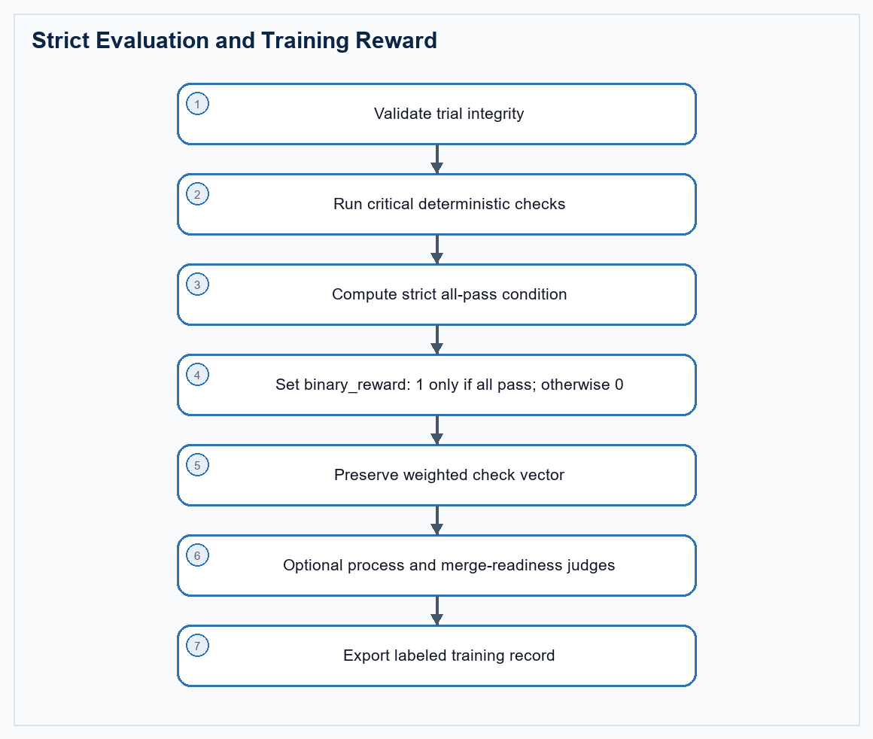
Figure 7. Strict success remains binary while valid partial work receives labeled training signals.
Output | Meaning | Use | Rule
binary_reward | Strict benchmark success | Leaderboard and eval pass rate | 1 only when every critical deterministic gate passes
training_score | Weighted deterministic progress | Curriculum, credit assignment and near-miss ranking | Never reported as a solved task
valid_trial | Evaluation boundary remained intact | Training eligibility and quarantine | Zero for contamination or invalid harness state
fail_to_pass | Original and hidden behavior repaired | Behavioral learning signal | Derived only from executable checks
pass_to_pass | Relevant prior behavior preserved | Regression-safety signal | Separate from new behavior
repo_integration | Cross-component contract is coherent | Integration and migration training | Includes real callers or repository scenarios
merge_ready_score | Quality of a strict-passing patch | Preference data and review research | Zero or unreported unless deterministic success holds

Non-deterministic checks
Judges are useful for diagnosis quality, repository conventions, patch minimality, architecture taste, reviewability, and suspicious trajectory review. They should receive only bounded evidence: instruction, changed files, patch, selected logs, reward details, declared artifacts, and trajectory. Run repeated judges or human audits when a score matters. Judge disagreement is uncertainty, not deterministic truth.
Two separate reward passes
Run executable checks and the deterministic RewardKit suite inside the offline task. Run process, validity, task-quality, and merge-readiness judges in a separate controlled or post-hoc pass. Preserve reward and binary_reward from deterministic evaluation even when a judge is unavailable or disagrees.

Reward implementation templates

RewardKit aggregation
# Run this aggregation only over deterministic dimensions.
[[reward]]
name = "reward"
aggregation = "threshold"
threshold = 1.0
[[reward]]
name = "binary_reward"
aggregation = "threshold"
threshold = 1.0
[[reward]]
name = "training_score"
aggregation = "weighted_mean"

Verifier entrypoint pattern
#!/usr/bin/env bash
set -uo pipefail
RESULT_DIR="${RESULT_DIR:-/logs/verifier}"
TESTS_DIR="$(CDPATH= cd -- "$(dirname -- "${BASH_SOURCE[0]}")" && pwd)"
ENGINE="$TESTS_DIR/deterministic/engine.py"
SUITE_DIR="$RESULT_DIR/deterministic_suite"
REWARDKIT_OUT="$RESULT_DIR/rewardkit_deterministic"
mkdir -p "$RESULT_DIR" /app/output
# First run the real repository checks. The engine writes granular executable
# evidence; it must not fetch dependencies during a scored trial.
python3 "$ENGINE" >"$RESULT_DIR/engine_output.log" 2>&1 || true
cp "$RESULT_DIR/reward.json" "$RESULT_DIR/deterministic-engine-reward.json" 2>/dev/null || true
cp "$RESULT_DIR/reward-details.json" "$RESULT_DIR/deterministic-engine-details.json" 2>/dev/null || true
# Keep conventionally named tests visible to validators and human reviewers.
DETERMINISTIC_DETAILS_PATH="$RESULT_DIR/deterministic-engine-details.json" \
PYTHONPATH="$TESTS_DIR/deterministic${PYTHONPATH:+:$PYTHONPATH}" \
pytest -q -p no:cacheprovider "$TESTS_DIR/test_reward_contract.py" \
"$TESTS_DIR/deterministic"/test_*.py \
>"$RESULT_DIR/test_output.log" 2>&1 || true
# RewardKit aggregates only deterministic criteria here. Optional judges are
# deliberately excluded from this suite.
rm -rf "$SUITE_DIR" "$REWARDKIT_OUT"
mkdir -p "$SUITE_DIR/deterministic" "$REWARDKIT_OUT"
cp "$TESTS_DIR/reward.toml" "$SUITE_DIR/reward.toml"
cp "$TESTS_DIR/deterministic/check.py" "$SUITE_DIR/deterministic/check.py"
status=0
DETERMINISTIC_DETAILS_PATH="$RESULT_DIR/deterministic-engine-details.json" \
rewardkit "$SUITE_DIR" --workspace /testbed \
--output "$REWARDKIT_OUT/reward.json" \
>>"$RESULT_DIR/test_output.log" 2>&1 || status=$?
# Merge strict RewardKit truth with the executable training vector. The sync
# script writes numeric zero on infrastructure failure instead of no reward.
python3 "$TESTS_DIR/sync_reward.py" "$RESULT_DIR" "$REWARDKIT_OUT" "$status"
# Optional process, validity and merge-readiness judges run separately or
# post-hoc. They must never overwrite binary_reward or rescue deterministic
# failure.
exit 0

10. Authoring and Acceptance
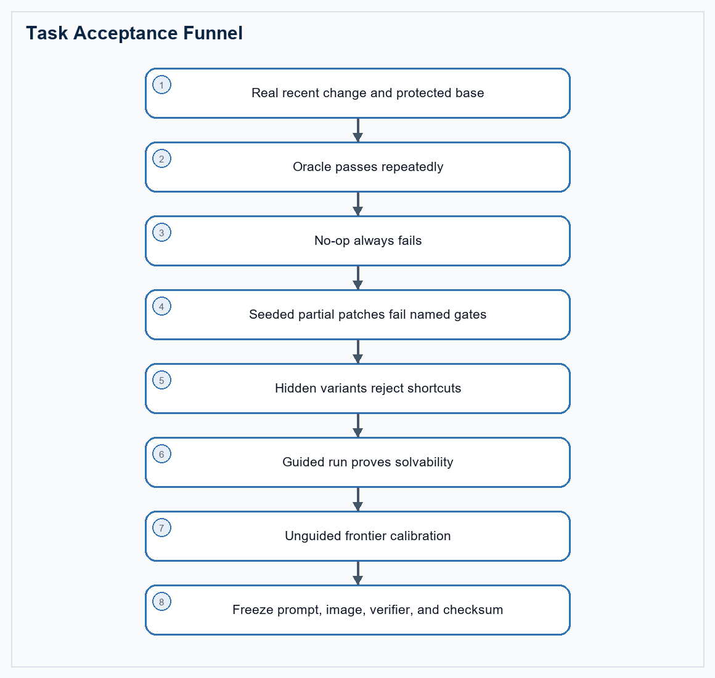
Figure 8. A task is accepted only after solvability, shortcut rejection, and frontier headroom are demonstrated.
- Select stateful, cross-component work involving runtime behavior, data contracts, migrations, concurrency, performance, faults, or compatibility rather than patch size alone.
- Keep the exact PR, issue, merge commit, and Oracle privately for provenance; remove all of them from the agent-visible image and prompt.
- Require Oracle success in repeated clean builds and no-op failure in every run.
- Seed at least three plausible near misses: narrow symptom patch, over-broad behavior change, and incomplete integration or regression update.
- Confirm hidden verifiers reject at least 90% of authored near-miss mutations before accepting the task.
- Calibrate multiple frontier agents and investigate trajectories, not only aggregate scores.
- Freeze the prompt, base image, verifier, dependency versions, and task checksum together.

11. Evaluation-to-Training Use
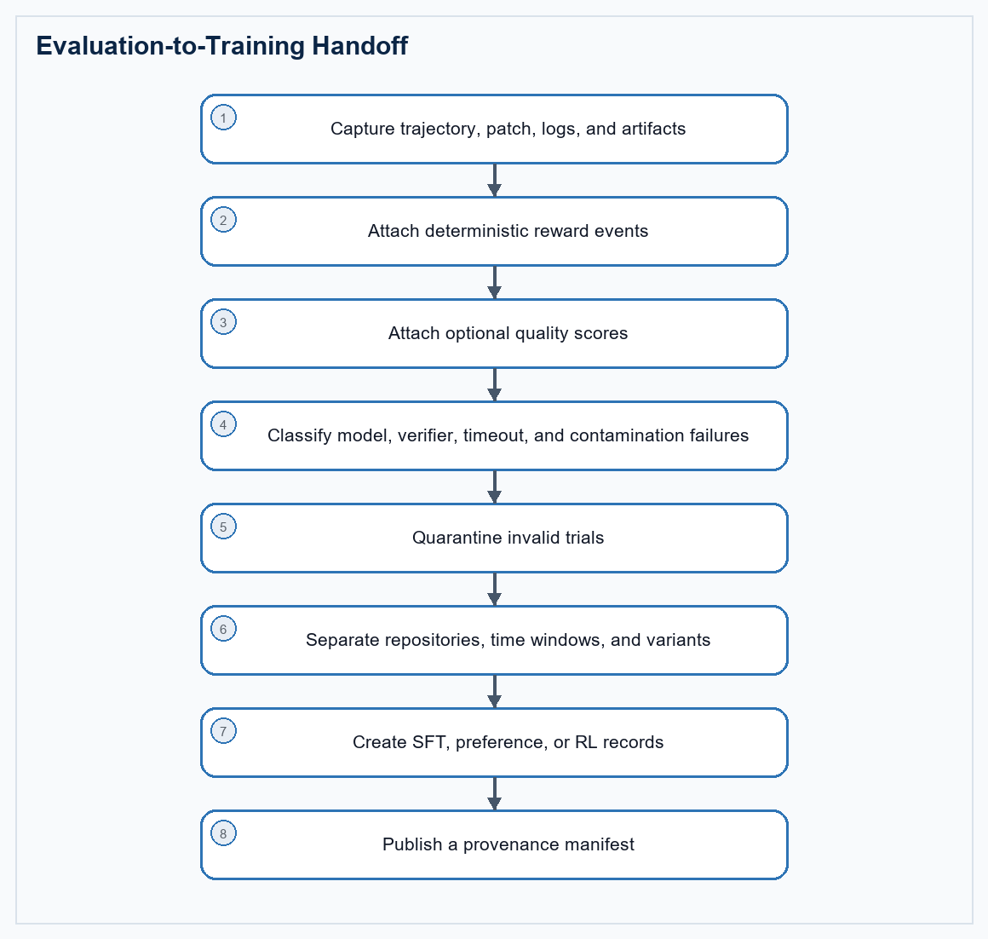
Figure 9. Valid trials become labeled training records without leaking evaluation instances.
- Export full trajectories, repository snapshots or patches, commands, test outputs, reward events, artifacts, failure labels, contamination labels, and optional judge reasoning.
- Retain valid failed trials and near misses because they show localization, implementation, regression, or integration boundaries.
- Create pairwise preferences only from comparable valid trials, such as strict pass versus near miss or focused patch versus bloated strict pass.
- Never train on an active evaluation instance. Separate training and evaluation by repository, time window, hidden variant, and task checksum.

12. Worked Example Retained from the Earlier Guide
Example, not template
The earlier UV task remains useful as a calibration case. It is based on a real Rust resolver migration, but the generic package and verifier rules in this guide should be applied to any suitable repository and language.

Example fact | Observed value | Lesson for generic Tier 1 design
Source | UV PR #20302 at its exact pre-change commit | Use real provenance privately and sanitize it from the solving environment
Scope | Resolver behavior, repository scenarios, CLI/settings, generated schema and documentation | Grade one contract across multiple repository representations
Oracle | Strict deterministic pass | The author solution must prove repeatable solvability
Frontier trial | 13 of 16 checks; strict 0; weighted training score 0.70 | Partial vectors explain progress without inflating pass rate
Failure families | Architecture cleanup, repository scenarios, documentation/schema consistency | A plausible local fix is not enough when the full repository remains inconsistent
Patch identity | No comparison with golden.patch | Evaluate behavior and declared architecture, not line-for-line similarity

Fresh-container validation of the package pattern
The finalized UV package was rebuilt and its verifier was run directly in fresh Docker containers. These values validate the packaging and reward path; they are an example calibration record, not universal reward targets for every Tier 1 task.
Trial | Observed result | What it proves
No-op | binary_reward 0.0; training_score 0.51; valid_trial 1.0; rewardkit_available 1.0 | An untouched repository fails strict behavior while still producing a valid, useful partial training vector
Oracle | All 16 deterministic criteria passed; binary_reward, training_score, integration, regression and process values were 1.0 | The author solution is solvable through the complete executable verifier and RewardKit path
Runtime | Python 3.12.13; pytest 8.3.5; harbor-rewardkit 0.1.7; Rust 1.97 | A non-Python repository can carry a separate pinned verifier runtime without changing its main toolchain
Network policy | One environment allow_internet = false baseline; no agent or verifier network_mode override | Agent and verifier inherit one startup policy, avoiding unsupported phase policy changes
Discovery | Five conventionally named test_*.py modules plus tests/test.sh and reward.toml | The package is visible to Harbor-style validators and still retains a richer executable engine

13. Final Author Checklist
- task.toml uses schema_version 1.3 and declares metadata.benchmark_type = swe-bench.
- environment.allow_internet is false and agent/verifier sections do not override network policy.
- tests/test.sh, tests/reward.toml, and at least one tests/deterministic/test_*.py file are present in the packaged artifact.
- The verifier interpreter satisfies RewardKit's requirement and pytest/rewardkit resolve from the pinned isolated environment.
- The full repository and all locked dependencies build without network access during the scored run.
- The prompt states behavior, preserved contracts, constraints, and executable evidence without revealing provenance or a patch recipe.
- Critical deterministic checks cover fail-to-pass, pass-to-pass, integration, artifacts, and integrity.
- Source-shape checks exist only for explicitly required architecture or security boundaries.
- Optional judges are bounded, reproducible where possible, and unable to change binary truth.
- Oracle, no-op, seeded near misses, guided runs, and multiple frontier trials have all been reviewed.
- Every verifier exit path writes a numeric reward and enough logs to classify failure.
- Training exports are separated from active evaluation repositories, windows, variants, and checksums.

14. Source Map
Harbor task and RewardKit guidance was checked against the current official documentation on July 13, 2026. Source-change identity belongs in private author provenance or a worked example, not in the protected agent instruction.
Source | URL | Used for | Planning decision
SWE-bench | swebench.com | Issue-to-patch repository evaluation and regression tests | Keep executable behavior and pass-to-pass safety
SWE-Bench Pro | labs.scale.com | Professional repositories and reproducible task containers | Use real full repositories, strong tests and protected splits
Senior SWE-Bench | senior-swe-bench.snorkel.ai | Natural briefs, runtime verification, taste and difficult investigations | Keep deterministic correctness separate from merge readiness
Senior SWE-Bench tasks | github.com | Concrete Harbor-compatible task packages | Reuse package discipline while strengthening long-horizon and contamination controls
Harbor task documentation | harborframework.com | Task, agent, environment, verifier, reward and artifact model | Use one reproducible package and explicit reward files
Harbor task structure | harborframework.com | Required instruction, environment, solution, tests/test.sh and numeric reward contract | Keep test.sh as the stable verifier entrypoint and use absolute container paths
Harbor RewardKit | harborframework.com | Programmatic criteria, judge criteria, reward dimensions and reward.toml aggregation | Separate deterministic truth from optional quality review
Harbor task tutorial | harborframework.com | Discoverable test_*.py convention and Oracle/no-op workflow | Ship at least one conventionally named deterministic test module
UV worked example | github.com | Recent full-repository Rust resolver change used to calibrate the earlier guide | Retain as an example, not as the generic task template

